Demo: Keeping Only the Target House's Mailboxes
Worked example: Itterbeeksebaan 226C (MDU), Dilbeek. A neighbour's mailbox was detected along with the target's.

1. The case
Item | Value
Address | Itterbeeksebaan 226C, box 201, 1701 Dilbeek
Type / use | MDU, business use (Zakelijk)
Address point (X, Y) | 141335.941, 169869.409 (assumed EPSG:31370, to be confirmed)
Building ID | 20419191
Problem | The detector returns 4 mailboxes: 1 on the left neighbour's wall and 3 beside the target entrance. The correct answer for the target is the bank of 3.

Note on this demo: the image is a Street View screenshot. The boundary column (about x = 265 px) was estimated by eye from the facade change, to illustrate the idea. In the real pipeline this column comes from projecting the CadGIS parcel frontage using the panorama position and heading. The red hand-drawn circles in the figures were already on the original screenshot.

2. Step-by-step demonstration

Step 1: run the detector on the clean image
RF-DETR sees only objects, not addresses or parcels. It returns four mailbox boxes: M1 on the left house and M2 to M4 at the entrance on the right. Counting all of them gives 4, which is wrong.
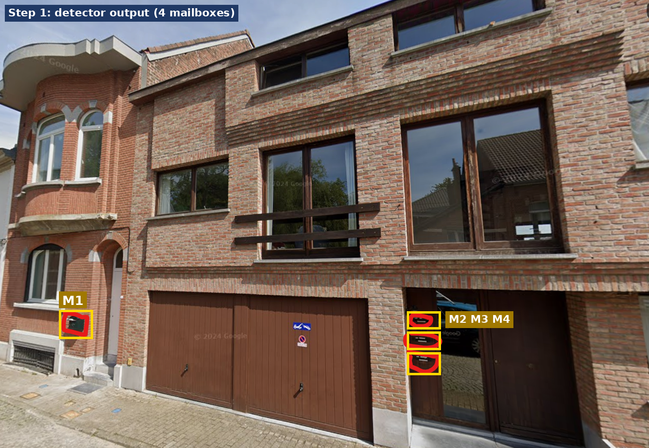
Figure 1. Detector output: four mailboxes, no ownership information.

Step 2: project the target frontage into the image
From the address point we find the parcel, take its street edge A-B, and compute the bearing from the panorama to A and to B. Each bearing maps to a pixel column. Everything between those columns is the target frontage; everything outside it belongs to a neighbour. A buffer (amber band) absorbs positioning error.
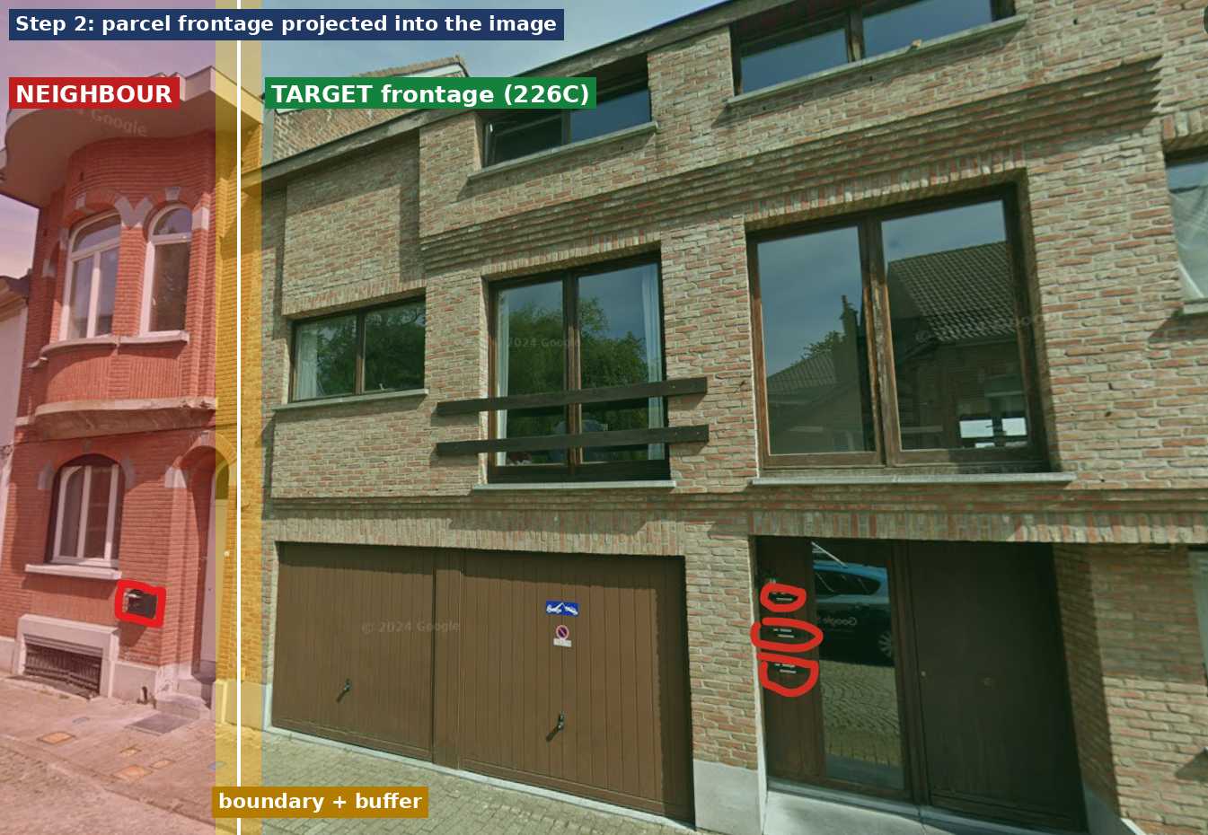
Figure 2. Red: neighbour. Green: target frontage. Amber: buffer around the boundary.

Step 3: filter the detections and check the doors
Each detection's centre column is compared with the frontage range. M1 falls in the neighbour zone and is rejected. M2 to M4 fall inside the target range and are kept. A door check agrees: M1 is next to the neighbour's arched door, while M2 to M4 are at the target entrance.
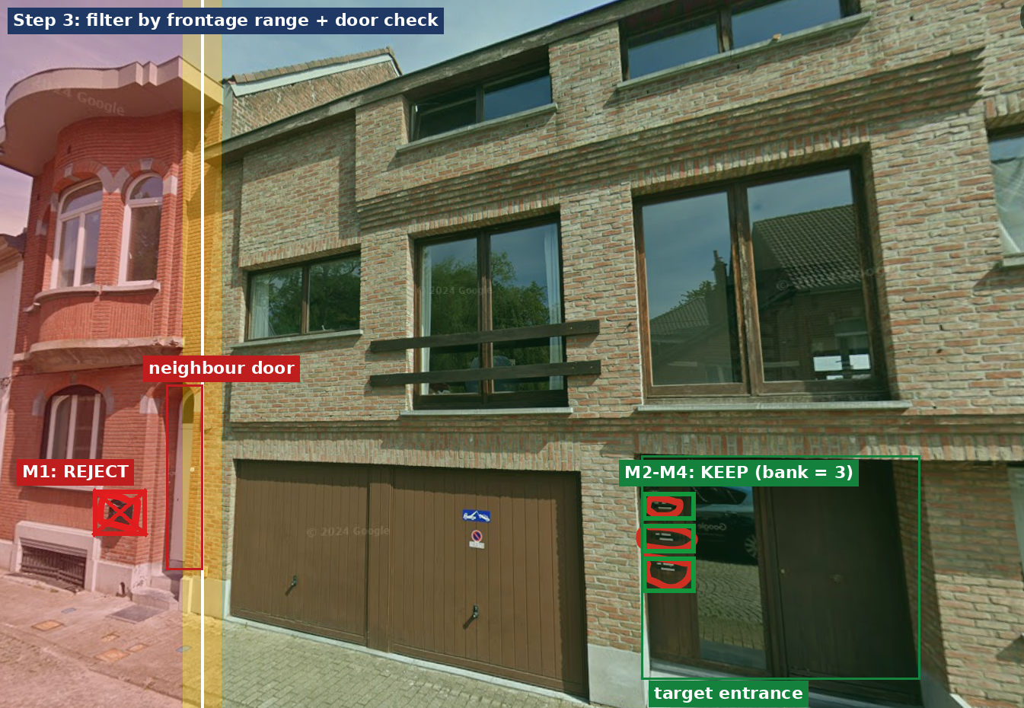
Figure 3. M1 rejected (outside range, neighbour door). M2-M4 kept (inside range, target entrance).

Step 4 (optional): blur the rest for review images
For human review or a client demo, everything outside the target range can be blurred. The decision itself should still come from the filter in Step 3, not from the blurred image, because a hard mask can cut off a real mailbox if the boundary is a little off.
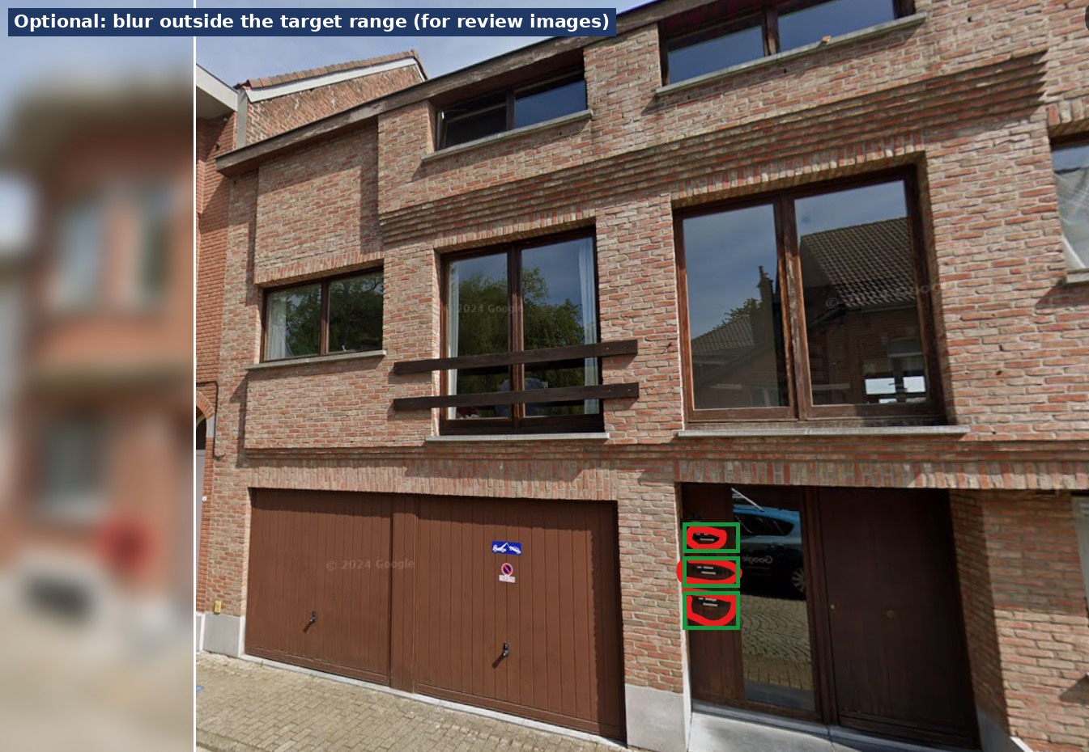
Figure 4. Neighbour blurred; the target frontage and its mailbox bank remain sharp.

3. Result
Detection | Centre column | Test result | Decision
M1 | ~155 px | Outside range (boundary ~265); next to neighbour door | Reject: neighbour
M2 | ~880 px | Inside range; at target entrance | Keep
M3 | ~880 px | Inside range; at target entrance | Keep
M4 | ~880 px | Inside range; at target entrance | Keep

Final output: MDU mailbox bank with 3 mailboxes at the target entrance. Individual slots are counted, not tied to apartments. Neighbour mailbox excluded.

4. The core filter (what the demo implements)
# 1) frontage columns in this panorama
xa, xb = sorted([bearing_to_col(bearing(pano, A), heading, fov, W),
bearing_to_col(bearing(pano, B), heading, fov, W)])
buf = angular_margin_px(0.75, dist_to_frontage) # ~0.75 m buffer

# 2) keep detections whose centre is inside the range
keep = [d for d in detections
if d.cls in ("mailbox", "mailbox_bank")
and xa - buf <= (d.x1 + d.x2) / 2 <= xb + buf]

# 3) door check + MDU grouping on the kept set

5. Caveats to mention in the demo
- Which entrance is 226C? The suffix "C" suggests other entrances (226A, 226B) may share this facade. The three slots belong to 226C only if that entrance is inside the 226C parcel. Confirm with the building footprint (building_id 20419191).
- Easy case. The leaked mailbox is far from the boundary. The hard case is a mailbox within 1 to 2 m of the boundary; there the pipeline uses the door rule and a second panorama, and may return Ambiguous.
- One panorama is not proof. Positioning error of a few metres can shift the range. Using two or more panoramas and triangulating raises confidence.
- Business use. The record is Zakelijk, so the mailboxes at this entrance may be business mailboxes. They are counted the same way.
- Unverified inputs. The X/Y coordinate system and the meaning of HASLength (0 here) should be confirmed with the data owner.

6. Suggested demo script
- Show Figure 1: "The detector finds four mailboxes, but only three belong to this address."
- Show Figure 2: "We project the parcel frontage from the cadastre into the image. Green is this property; red is the neighbour."
- Show Figure 3: "Each detection is tested against that range and against the nearest door. The left mailbox is rejected."
- Show Figure 4: "For review we can also blur the neighbour, but the decision comes from the geometry."
- Close with the result table: MDU, bank of 3, neighbour excluded; ambiguous cases go to a second panorama or review.

